An introduction to the theory and movement of Intelligent Design

- What is Intelligent Design (ID)?
  - A scientific theory that proposes that certain observed features in nature are best explained by an intelligent cause as opposed to chance-based processes
  - A scientific, political, and educational movement that seeks to provide scientific questions, discussion, and answers that oppose Darwinian naturalism as a mechanism for observations
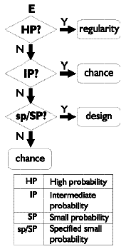
- Some visible proponents
  - William Dembski, mathematician, philosopher, theologian.
    - Author of The Design Inference: Elimination Chance Through Small Probabilities
    - Editor of Uncommon Dissent: Intellectuals Who Find Darwinism Unconvincing (2004)
    - Complex Specified Information indicate intelligent agent
    - Law of conservation of information
    - Law of small probabilities
    - Explanatory Filter
  - Michael Behe, biochemist,
    - Author of Darwin's Black Box: The Biochemical Challenge to Evolution
    - Irreducible complexity: some systems are too complex to have evolved
    - Examples: bacterial flagellum, immune system, blood clotting
  - Stephen C. Meyer, science philosopher
    - Author of Signature in the Cell: DNA and the Evidence for Intelligent Design
    - Analyzes biological information
    - Complexity points to intelligence (akin to Behe)
    - More politically active than others
- ID Theory as science
  - Explicitly makes no claim on the nature of the intelligence
  - No statement on age of the universe/earth
  - Avoids theological arguments or positions: No statement on the compatibility of science and religion, explicitly different than creationism
  - Goal is to work within science
  - Predictions: complex biomachines, fine-tuned physics, rapid fossil appearance, “engineering”-like reuse of functional systems, useful genetic codes in DNA
- Scientific evidence of ID?
  - Anthropic coincidences in cosmology
  - Statistical impossibility of random formation of even a single protein
  - “Miracle” of mathematics as a language of science—Eugene Wigner
- Conclusion
  - ID is not a religion—caution about attaching Christianity to it, but vice versa is appropriate
  - ID is not accepted as science under the contemporary scientific paradigm, but science, if truth-seeking, may have to assent to external intelligence

